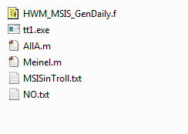
Fortran file that runs MSIS00 to get background atmosphere

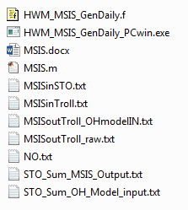
Executable version of above for PC windows (fortran 77)
Input file for MSIS specifying lat, long, day, F10.7 and AP

Run the HWM_MSIS_GenDaily_PCwin executable. It give you the option of specifying the solar depression angles over which to average the data (answering “y”) or using the entire day (if you answer “n”). It then prompts for the input file name, and the output file name. After running MSIS to obtain the background atmosphere, one needs these files in your directory:
Output file from MSIS model
Output file from MSIS model, edited to include only those altitudes with non-zero O and H densities
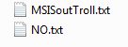
The specified NO mixing ratio vs. altitude. Note, must have the
same altitudes as the MSIS background model file.
Matlab driver to calculate rate coefficients with T(z) from MSIS
Matlab driver to calculate steady state O3 and OH density

The Matlab calling sequence for AllA.m is: AllA(‘MSISoutTroll_OHmodelIN.txt’) . This will use the temperature profile from your background MSIS atmosphere to calculate the rate coefficients for the production and quenching of OH and O₃ as a function of altitude.
The next routine to run from Matlab is the Meinel.m with the calling sequence: Meinel(1). Here “1” is the scaling factor for the atomic oxygen density in the MSIS background atmosphere. This is based on paper saying that the atomic oxygen density in MSIS is over/under estimated during different solar conditions. So one can scale the O density at each altitude by 0.5 by calling: Meinel(0.5).
Note that in AllA.m, there are several paths set where the transition probabilities for OH radiation and the rate coefficients for the reactions are stored. In my case, I have them set to:
% Einstein Co-efficent data from Langhoff(1986) data
% REF: Stephen R. Langhoff, H-J Werner and P. Rosmus, Theoretical
% Transistion probabilities for the OH Meinel System, [J. Mol. Spec.,
% 118, 507-529 (1986)]
addpath C:\Users\espy\Documents\MATLAB\work\OH_Model_run\LanghoffData\Delta1;
addpath C:\Users\espy\Documents\MATLAB\work\OH_Model_run\LanghoffData\Delta2;
addpath C:\Users\espy\Documents\MATLAB\work\OH_Model_run\LanghoffData\Delta3;
addpath C:\Users\espy\Documents\MATLAB\work\OH_Model_run\LanghoffData\Delta4;
addpath C:\Users\espy\Documents\MATLAB\work\OH_Model_run\LanghoffData\Delta5;
% Directory where the rate coefficient files are stored
addpath C:\Users\espy\Documents\MATLAB\work\OH_Model_run\rates;

However, these lines in AllA.m can be changed depending upon where you want to store this data on your system. Note, this is a nightglow model for the OH(v’) densities and radiance and must be modified for daytime conditions, and currently does not contain the HO₂ chemistry.
To obtain the Intensity vs. altitude and density vs. altitude for the various OH levels and bands, see file ModelFileData.doc.
There is a directory called demo that has all the model input files and matlab model files needed to generate the OH for Troll station Antarctica. Note that the addpath statement in the matlab files must be modified as mentioned above.

